Object Oriented Data Structures
(CL2021)

LABORATORY MANUAL
BS-EE, Fall 2026

LAB 01

CLASSES, CONSTRUCTORS, AND CLASS RELATIONSHIPS

M. Nafayh Akhlaq | 25i-6180 | EE-C
________________________________________ | __________ |  | ____
STUDENT NAME | ROLL NO |  | SEC
______________________________________
LAB ENGINEER'S SIGNATURE & DATE
Engr. Zulkaif Sajjad
MARKS AWARDED: /10
_____________________________________________________________
NATIONAL UNIVERSITY OF COMPUTER AND EMERGING SCIENCES (NUCES), ISLAMABAD

Prepared by: | Engr. Zulkaif Sajjad | Version: | 1.1
Verified by: | Engr. Shahid Qureshi | Date last edited: | Aug 17, 2026

LAB OBJECTIVES:
- Understand class structure in C++
- Implement different types of constructions
- Apply class relationships

1. Class
Definition: A class is a blueprint that defines data members and functions to model a real-world entity.

Syntax
class ClassName {
private:
// data members
public:
// member functions
};

Example
#include <iostream>
using namespace std;

// Student class definition
class Student {
private:
int id; // stores student ID
float gpa; // stores student GPA

public:
// function to set data
void setData(int i, float g) {
id = i;
gpa = g;
}

// function to display data
void display() {
cout << "ID: " << id << endl;
cout << "GPA: " << gpa << endl;
}
};

int main() {
Student s1; // object creation
s1.setData(101, 3.45); // setting values
s1.display(); // displaying values
return 0;
}

2. Constructor
Definition: A constructor is a special member function that initializes objects automatically at creation.

Syntax
ClassName() {
// initialization code
}

3. Types of Constructors

3.1 Default Constructor
Definition: A constructor with no parameters.

Syntax
ClassName();

Example
#include <iostream>
using namespace std;

class Course {
private:
string name; // course name

public:
// default constructor
Course() {
name = "OOP Lab";
}

// function to display course name
void show() {
cout << "Course: " << name << endl;
}
};

int main() {
Course c; // object created, constructor called
c.show();
return 0;
}

3.2 Parameterized Constructor
Definition: A constructor that takes parameters to initialize data members.

Syntax
ClassName(type var);

Example
#include <iostream>
using namespace std;

class Teacher {
private:
string name; // teacher name
int experience; // years of experience

public:
// parameterized constructor
Teacher(string n, int e) {
name = n;
experience = e;
}

// function to display teacher data
void display() {
cout << "Name: " << name << endl;
cout << "Experience: " << experience << " years" << endl;
}
};

int main() {
Teacher t("Ali", 10); // constructor called with arguments
t.display();
return 0;
}

3.3 Constructor Overloading
Definition: Multiple constructors in a class with different parameter lists.

Example
#include <iostream>
using namespace std;

class Lab {
private:
int computers; // number of computers

public:
// default constructor
Lab() {
computers = 20;
}

// parameterized constructor
Lab(int c) {
computers = c;
}

// function to display information
void show() {
cout << "Computers in Lab: " << computers << endl;
}
};
int main() {
Lab l1; // calls default constructor
Lab l2(35); // calls parameterized constructor

l1.show();
l2.show();
return 0;
}

4. Class Relationships

4.1 Has-A Relationship (Composition)
Definition: One class contains an object of another class.

Example
#include <iostream>
using namespace std;

// Processor class
class Processor {
public:
void info() {
cout << "Processor: Intel i7" << endl;
}
};

// Computer class has a Processor
class Computer {
private:
Processor p; // object of Processor class

public:
void show() {
p.info(); // accessing Processor function
}
};

int main() {
Computer c; // Computer object created
c.show();
return 0;
}

4.2 Uses-A Relationship
Definition: One class uses another class through function parameters.
Example
#include <iostream>
using namespace std;

// File class
class File {
public:
void open() {
cout << "File opened successfully" << endl;
}
};

// Editor class uses File
class Editor {
public:
void edit(File f) {
f.open();
cout << "Editing file..." << endl;
}
};

int main() {
File f; // File object
Editor e; // Editor object

e.edit(f); // passing File object
return 0;
}

Lab Tasks

Task 1: Student Book Records (File-Based Input)
The department maintains a list of academic books in a text file. You are required to design a program that reads this data and stores it using a class-based approach.
Requirements:
- Create a Book class with the following private data members:
  - Book Title
  - Author Name
  - Price
- Implement the following in the Book class:
  - A default constructor
  - A parameterized constructor
  - Getter functions to access book details
- In main():
  - Read book records from a given file Books.txt
  - Store the data in an array of Book objects
  - Display all book records in a formatted manner
Note: No user input is required in this task. All data must be read from the file.
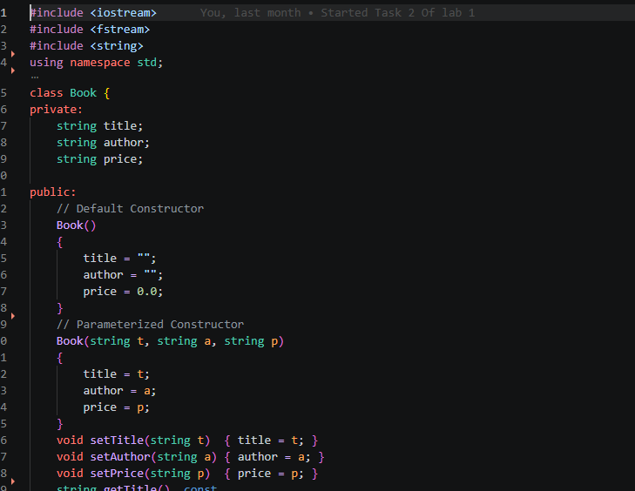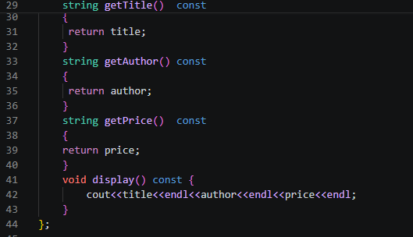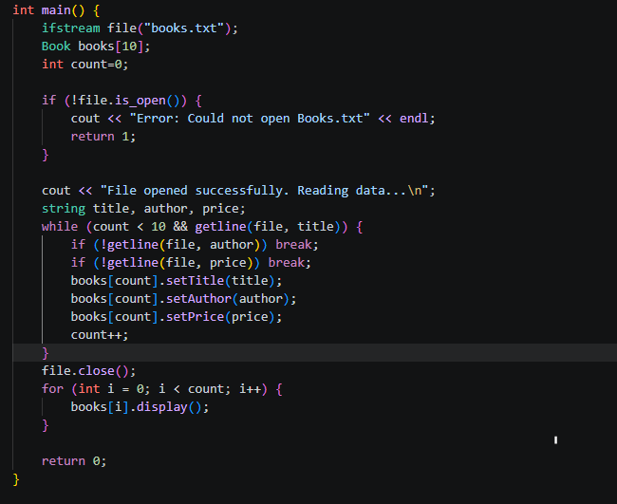
Output:
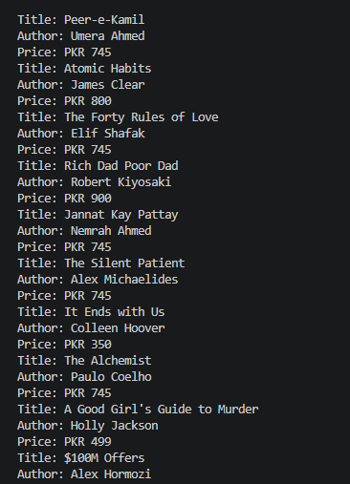

Task 2: Student–Book Relationship (Has-A Relationship)
Each student maintains a personal collection of study/reference books. This task demonstrates a Has-A relationship, where a student object contains multiple book objects.
Requirements:
- Create a Student class with the following data members:
  - Student Name
  - Roll Number
  - CGPA
  - An array of 7 Book objects (personal study books)
- Implement the following in the Student class:
  - Appropriate constructors
  - A composition (Has-A) relationship between Student and Book (a student owns books)
  - A function to display student details along with all owned books
- In main():
  - Take student name and roll number as input
  - Assign 7 books from the book list (Task 1) to the student
  - Display complete student information
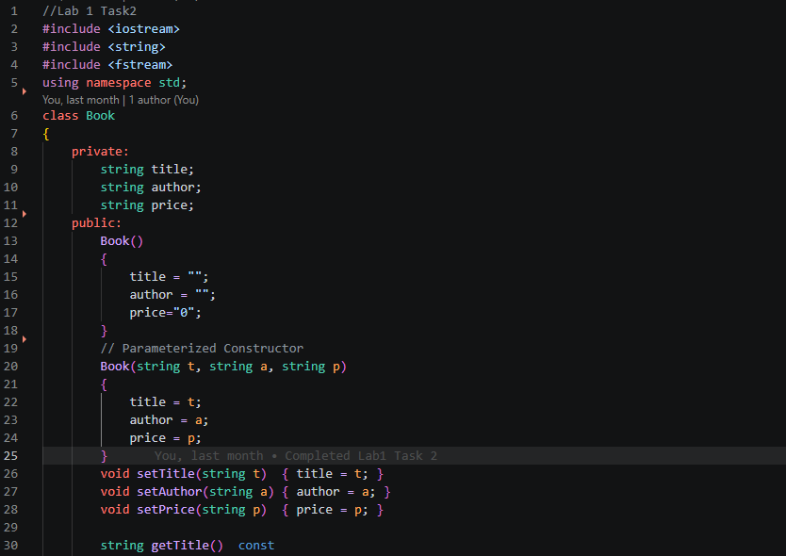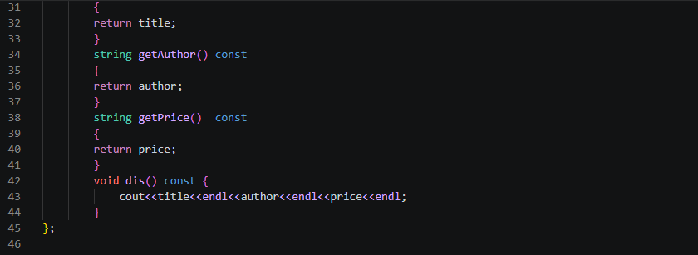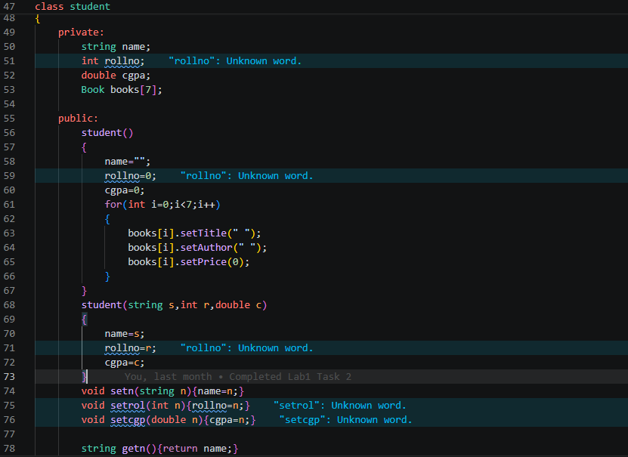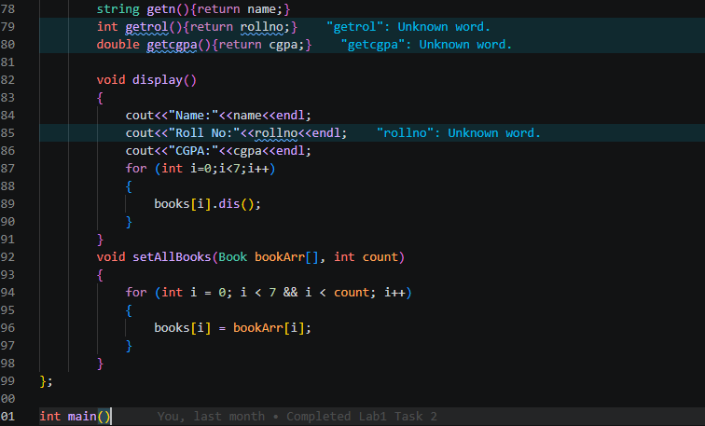
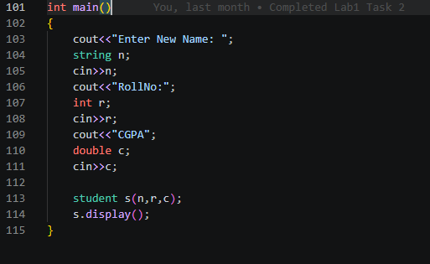
Bonus Task: Library Book Issuing System
A library issues books to students and keeps a record of borrowed books. The library does not permanently own student records but uses Student and Book objects to manage issuing operations.
Requirements:
- Reuse the Book and Student classes developed in previous tasks.
- Apply the following rules:
  - Each student can borrow up to 5 books
  - Books are issued temporarily and are not owned by the library
- In main():
  - Ask the user to enter the number of students
  - For each student:
    - Input name and roll number
    - Input the number of books to be issued (maximum 5)
    - Assign books from the available book list
- Display a consolidated report showing:
  - Total number of students
  - Number of books borrowed by each student
  - Names of books borrowed by each student
This task focuses on managing multiple objects, applying relationships correctly, and producing structured output.

